Briefing on Countdown 2030 Uganda Equity Analysis Results at 2019 RMNCAH Symposium

Introduction and Background
Every year the Ministry of Health with partners holds an Annual Reproductive Maternal Newborn Child & Adolescent Health Symposium/Assembly and the 2019 event was held from August 6th through August 8th at the Imperial Royale Hotel in Kampala. The Symposium/Assembly was held under the theme: “Better Accountability and Coordination for Reproductive Maternal Newborn Child and Adolescent Health.”

With over 700 participants including public and private stakeholders this year, the event seeks to annually establish a clear coordination and accountability mechanism to reduce on duplications and ensure efficiency and effectiveness in RMNCAH service delivery by all stakeholders in Uganda.

Health Minister Dr Jane Ruth Aceng officiated at the opening urging stakeholders to desist from choosing where to implement their projects and instead follow Government guidance on where there is need.

Several speakers ranging from youth representatives to country representatives of several UN and International NGOs graced the symposium and assembly. Among the keynotes speakers on August 6, 2019 was Prof Peter Waiswa of Makerere University School of Public Health who focussed on findings from the recent equity analysis under the auspices of the Countdown to 2030.

Countdown to 2030 Equity Analysis Results

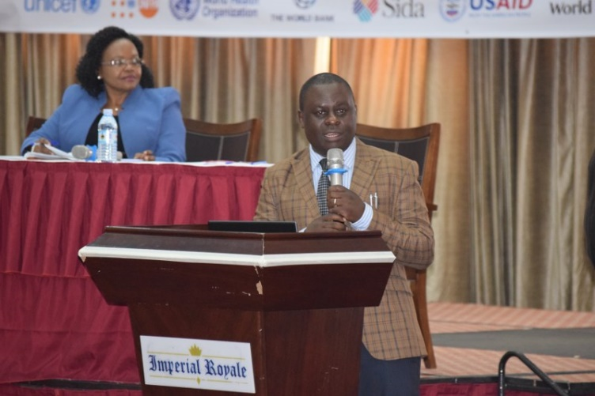
Prof. Peter Waiswa presents as Dr Jesca Nsungwa, Commissioner for Child Health, MoH, Chairs
The presentation was titled “Levels, trends and inequalities in indicators RMNCAH in Uganda; Leaving no woman and child behind.” Prof Waiswa first explained to participants how the unfinished business of the MDG agenda fed into the current global goals dubbed the Sustainable Development Goals. To achieve SDGs, he argued that there was need to address existing health inequities between (Rich & Poor, Rural & Urban, Slum & Non-slum), for all to have equitable coverage of basic health services.

Prof Waiswa said that Uganda has made huge advances in child health and even bridged inequities but not for mothers and newborns. He advised that this is an indication that the low hanging fruits or opportunities are almost gone, and any further progress will require more comprehensive programs including more attention to clinical services at the same time as we enhance PHC. He further said there was need for detailed analysis of health inequities related to MNCH in order to guide responsive policy and planning and accelerate progress towards ending preventable maternal and child deaths, regardless of where they live or their ability to pay.

The results he presented from the initial analysis (a joint venture by the Maternal newborn and Child Health Centre of Excellence of the Makerere University School of Public Health, the Planning Department at the Ministry of Health and the Africa Population and Health Research Centre) was the first in a planned series looking at demographic and health survey data, and facility based data.

From Prof Waiswa’s presentation, Karamoja region which has suffered the worst indicators since independence has now caught up with and surpassed some regions posting very good MCH indicators, other regions have caught up with Kampala city and other towns which seems static, and the near absence of primary health care in Kampala and other urban settings across Uganda, proved popular with participants. On the otherhand, the eastern, Bunyoro, and some areas in Northern Uganda are being left behind.

Reactions to the Countdown Equity Analysis Results
The presentation sparked nearly half an hour of comments. From the Napak District Health Officer to the Acting Commissioner for Community Health at the Health ministry, most speakers welcomed the equity analysis results with optimism.

“Thank you very much Peter. I am very excited about your presentation. Not only have you been able to communicate that we shall become a middle-income country, but you have been able to communicate that we are implementing shift one of our Sharpened Plan for RMNCAH/ Investment Case of targeting high impact interventions.

“I also hope the chair of District Health Officers has heard. We are having a retreat soon to discuss inequalities and this will come in handy.”

“We actually have an urban setting health policy developed in 2014 and the ministry is trying to update it. Again, this information comes in at the right time,” Dr Jesca Nsungwa, the Acting Commissioner for Community Health.

The Napak District Health Officer Dr James Lemukol and the CUAMM Country Representative Dr Peter Lochoro validated the findings saying they were a true reflection of the changes that have happened in Karamoja over the last decade. They cited deliberate efforts by the Uganda Government and partners especially UNICEF and the involvement of critical stakeholders right from families, communities, political and opinion leaders, as well as integrating RMNCAH issues into other service delivery sectors as part of the game changers in the Karamoja sub region for the improved child health indicators.
Others wanted to know why Kampala is being left behind and what can be done. Why are other regions doing well, and others not?

