  - Wednesday, 19 June

Practice 4: Coverage and equity
Duration: 1h50m

Sub-national profiles

Each country’s Countdown could develop its own format for its sub-national profiles, based on the country’s priorities, data availability, and selected geographical units. Here we will create some examples that could provide a useful starting point.
  - 1.1. Description of interventions across the continuum of care for selected geographical units
For this practice you will use the dataset stratified by regions ('gregions'):
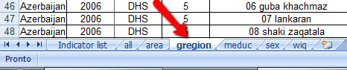
Let's observe the dataset structure by clicking on the tab 'gregion'. How the dataset is organized?
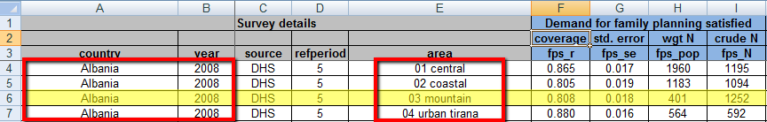
Notice that each row corresponds to one region for a country. This indicates that each region is one observation in dataset.

Let's compare two regions from your country. Choose two regions of your interest to work with. In my case, I will choose regions from the country 'Burundi'.

Find your country and the most recent survey. Identify the geographical units (regions) you would like to compare.
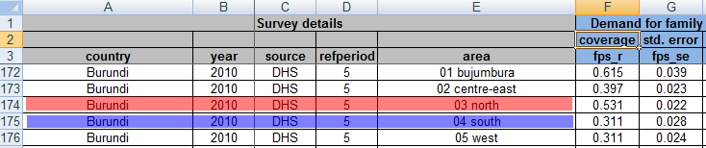
Open the spreadsheet named 'Working spreadsheet_Practice4.xls'. You will need to fill the tab named 'Table_sub-national' with data related to coverage (r) and standard errors (se).

Select these data from the tab 'gregion' from the file 'Completed equity dataset.xls' as you did in Practice 1:
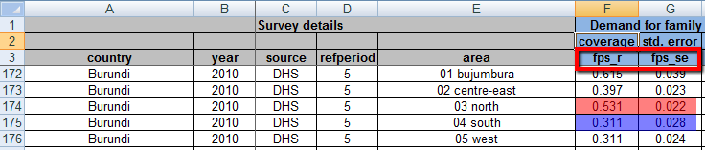

Fill out the spreadsheet in 'Working spreadsheet_Practice4.xls' as follows:
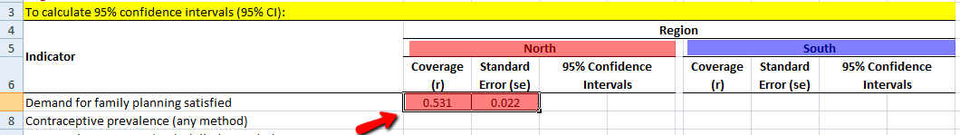

Now, let's calculate the 95% CI with the formulas learnt in Practice 1:

Lower 95% CI limit: r - (1.96*se)

Upper 95% CI limit: r + (1.96*se)

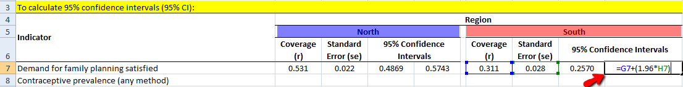
  - After filling out all the data for each indicators, fill out the Table 1 as follows:
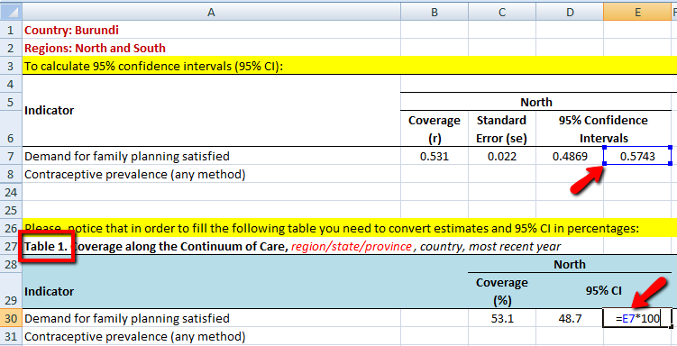
  - Now, let's create a figure in order to compare the two regions:
Paste the data on percent of coverage of indicators in the spreadsheet 'Figure_Sub-national'.
Select the cells that contain the information that you want to appear in the bar graph, this is the 'indicator' cells and 'coverage' cells . If you want the column labels to show up in the graph, ensure that those are selected as well.
Click the 'Insert' tab at the toolbar and select 'Column' in the 'Charts' section.
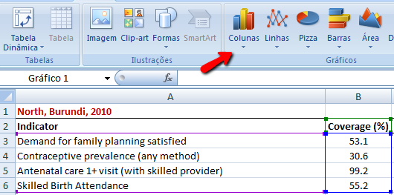
Select the '2-D Column' chart .
A bar graph like this will appear with the information of coverage selected:
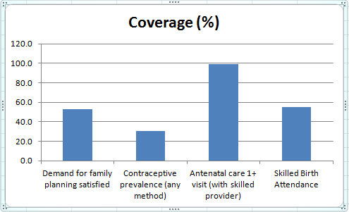
  - But you may want to represent the 95% CI. So you will need to copy the standard errors (se) from the tab 'Table_Sub-national' and paste them in the sheet 'Figure_Sub-national'.
Then you will need to follow the calculations as it is indicate:
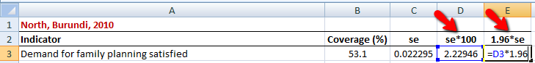
After completing calculations for all indicators, click on your graph and then on the Layout tab, click 'Error Bars', and then click 'More Error Bar Options'.
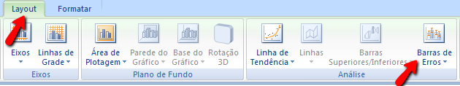
Under 'Error Amount', select custom values to determine the error amount, click 'Custom'.
Click 'Specify Value'.
In the 'Positive Error Value' and 'Negative Error Value' boxes, specify the worksheet range that you want to use as error amount values. In your case, this value is 1.96*se:
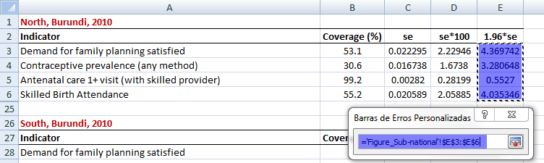
To specify the worksheet range, you can click the 'Collapse Dialog button', and then select the data that you want to use in the worksheet. Click the 'Collapse Dialog button' again to return to the dialog box.
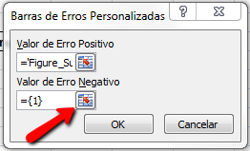
Now you have a figure that represents the coverage with a measure of variability:
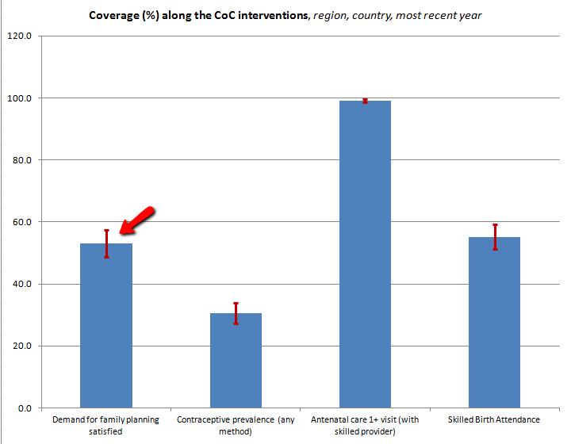
Repeat all the steps to create a table and a figure for the second region.
Compare the results and determine for which interventions there are inequities in coverage between the two regions.

  - 1.2. Description of indicators by country regions
For this practice you will use the dataset stratified by regions (tab 'gregions') as well.
Let's compare the coverage for two interventions across all the geographic units (region) of a country.

Choose two indicators of your interest to work with. In my case, I will choose skilled birth attendance and polio vaccination from the country 'Burundi'.

In the spreadsheet 'Working spreadsheet_Practice4.xls', click on tab 'Table_Byregion'.

Follow all the steps just learnt in the session above to create a table and figures to compare both indicators stratified by geographical units (regions).

Please recall plotting the percentage of coverage with a measure of variability. This will help you to recognize inequalities in the coverage of an intervention across the geographical units of a country.

